# Worksheet 1 Structure of the internet

### Task 1

1. Define the following Computing terms:  
   1. The Internet

A network of networks that allow computers to communicate globally

* 1. World Wide Web

A collection of webpages that reside on computers connected to the internet.

* 1. Backbone

The high capacity network of optical fibres and routers that form the core of the internet

1. Label the diagram of the structure of the different levels of the Internet, showing DNS servers, backbone, ISP servers, home, organisation and business users

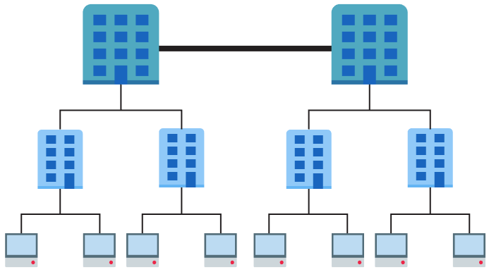

Bottom row – users, home, organisations,

2nd row – DNS servers, ISP servers,

Top row - backbone

1. IP version 4 addresses such as 13.1.67.234 and 115.90.12.101 are used to identify devices on a network. As such they need to be unique for each device.
   1. The value of each number in an IP address ranges from 0 to 255. Calculate how many addresses are possible in theory.

2^32 = 4294967296

* 1. Explain why version 4 is not enough for use on the Internet.

The number of available IPv4 addresses is in the billions, and there are more and more users beginning to use the internet everyday, some people may even have multiple devices on a network. This means we need more ip addresses but IPv4 doesn’t have enough, since the number of addresses it has that are available is quite small compared to how many people will be using the internet. It simply isn’t enough and we need IP versions with a larer number of available addresses so we can assign these addresses to new devices.

# Task 2

1. IP addresses are difficult for humans to remember. DNS provides a resolution of domains names and the IP addresses.

If you type 216.58.213.174 into the address bar of your browser, you should get the www.google.co.uk webpage.

We type the URL as it is easier to remember but it is just a label for the actual IP address that connects your computer to the Google servers.

Use the website <http://ping.eu/nslookup> to find the IP addresses of the following three websites and two more of your choice:

|  |  |
| --- | --- |
| **Website** | **IP address** |
| google.co.uk | **216.58.211.3** |
| bbc.co.uk | **151.101.64.81** |
| en.wikipedia.org | **185.15.59.224** |
| ocr.org.uk | **192.149.119.226** |
| britannica.com | **3.222.143.132** |

Check they work by typing them into a browser address bar. (Some only work in one direction.)

Compare your results with other people. They may be different. Can you explain why?

When you open the website, it requests it’s information from the closest server of that website, so for example with the google one above, my google ip address is slightly different from the one in the question. This is since the ip address I got is the address of a server that is slightly closer than the one in question, therefore to improve speed and efficiency this closer server is picked.

1. URLs are used to specify the location and means of accessing a resource across a network.   
     
   Correctly label the parts of the following URL with ‘**Domain name**’, ‘**Protocol**’, ‘**Resource**’:

http://foodsupermarket.com/cheeses.html

foodsupermarket – domain name

https - protocol

cheeses.html - resource

# Task 3

**Read the following explanation of “physical” vs “logical” network topologies:**

A “bus” is simply a wire or cable. At its simplest, a bus network is just two computers linked together by a wire. You can add more computers and join more computers to the bus network, but only one computer can use the bus at any one time.

In an Ethernet network, computers use a collision detection algorithm called CSMA/CD (Carrier Sense Multiple Access/Collision avoidance) to deal with this problem.

If the wire is too long, the signal degrades, so **hubs** were inserted to act as repeaters at various points. This allowed many **physical** buses to act like one **logical** bus.

It did not solve the problem of collisions, in fact it made the problem worse because it was easy to add more computers to the network.

If the **hub** is replaced by an intelligent **switch**, the switch knows which of the physical buses is attached to it, so a signal is sent only to the buses that the destination computer is attached to.

So what you now have is a number of computers connected to a switch – which, hey presto, is a physical star network! But it is still using a bus protocol, so it is a logical bus network.

**Explain in your own words the difference between a logical and physical topology.**

Physical topology is how the topology is laid out physically in real life, like how the cables are wired and to where, and from where etc.This shows what the topology operates on. Logical topology is how the network actually operates in practice, like for example if a hub is in the place of the switch in a star topology, it will operate like a bus topology because the hub directs the data through each device on the network until it finds the correct device / intended device the data is for. So although the network is physically laid out like a star topology, it functions like a bus.

# Task 4

**Advantages and disadvantages of each topology**

**BUS TOPOLOGY:**

|  |  |
| --- | --- |
| Advantages | Disadvantages |
| Simpler to setup | Data is sent through every device so poses security issues |
| Cheaper to setup | Slower than star since data collisions can occur causing data to have to be resent since its corrupted now |
| Less hardware needed | If one device in the network fails, it can cause problems for data transfer since data might have to go through this device, but since this has failed, data wont get through it to the end location since the route is blocked. |

**STAR TOPOLOGY:**

|  |  |
| --- | --- |
| Advantages | Disadvantages |
| Faster since switch directs data to the intended device immediately instead of passing through all devices until it reaches the desired one. | Expensive since a lot of cables needed for each device on network. |
| Secure since only intended computer receives the data, so harder for it to be intercepted by other devices on network | Harder to setup due to hardware and cabling and requiring more expertise. |
| If one device fails, the network continues to work since all devices are connected to the central node, rather than through each other. | If central node fails or breaks down, it affects all devices since it is responsible for all the data transfers. |